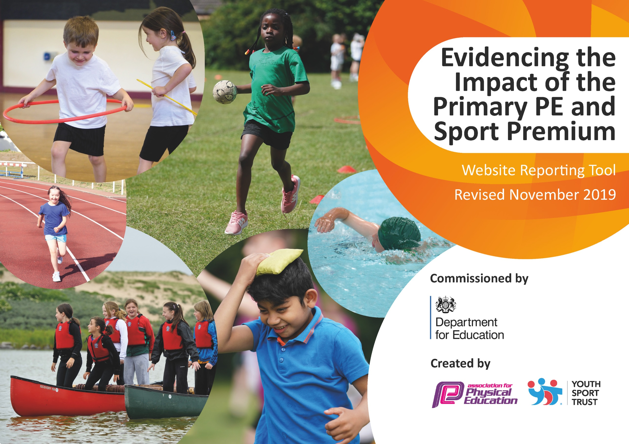
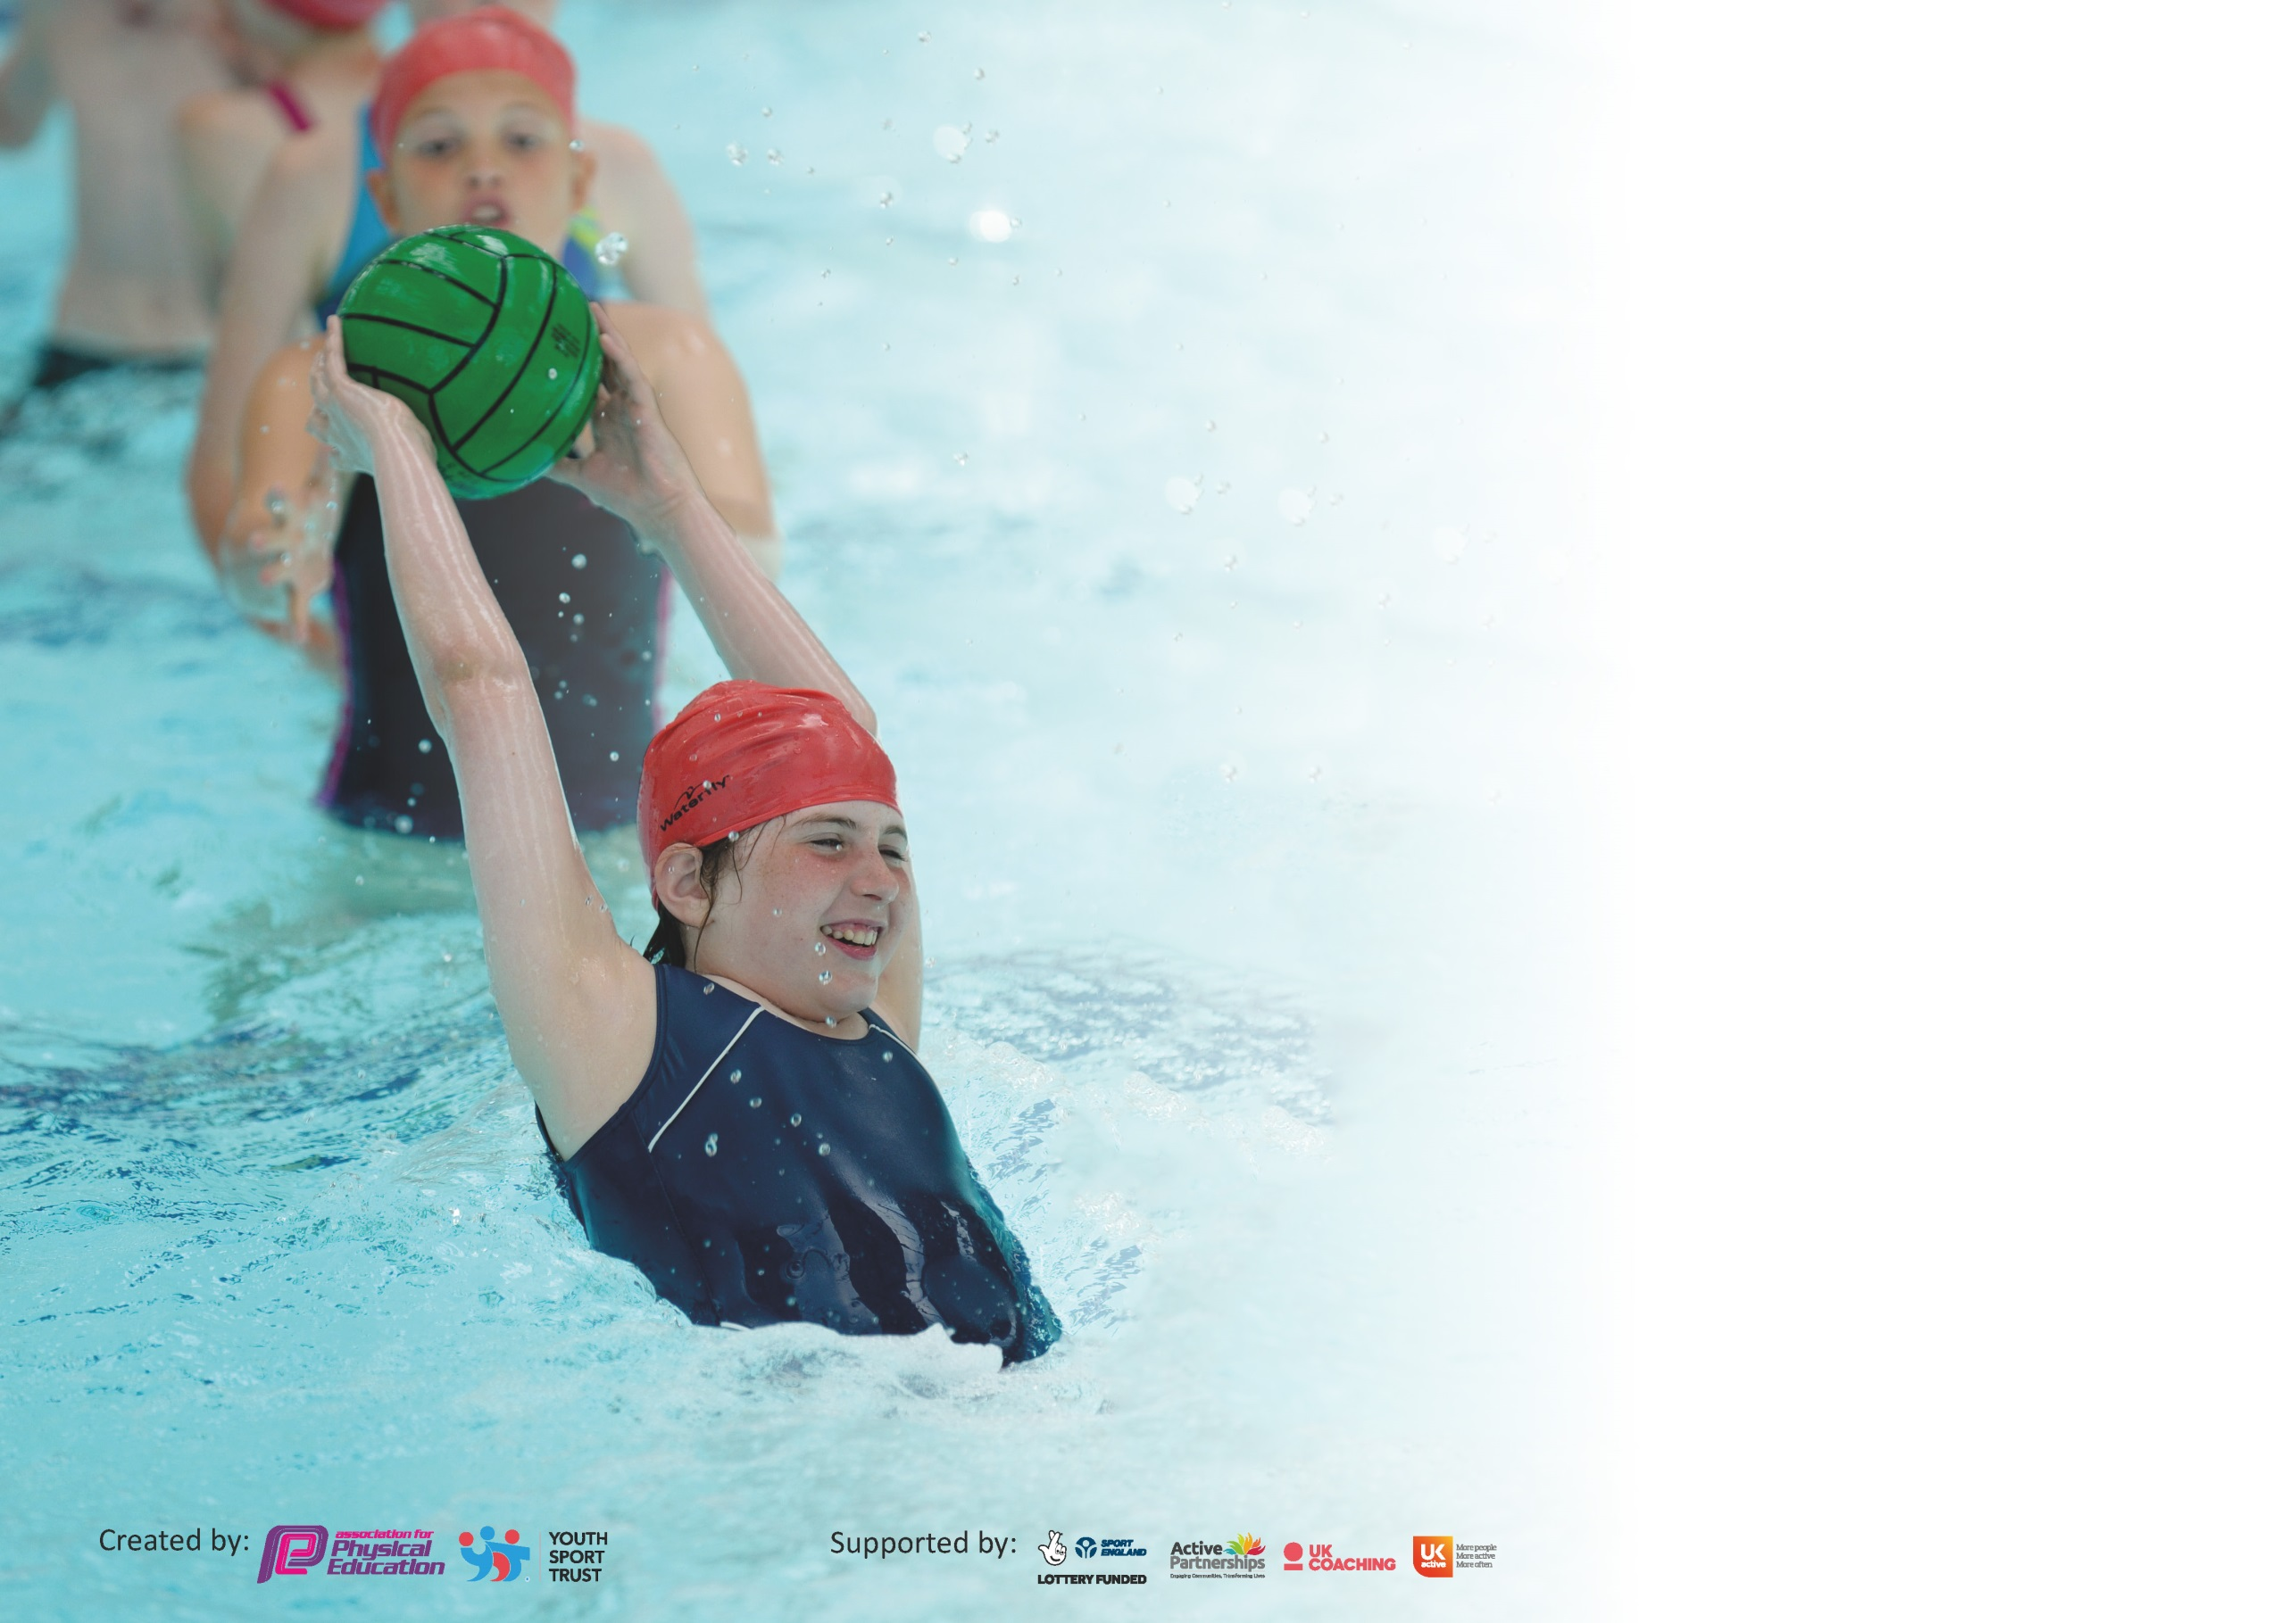

It is important that your grant is used effectively and based on school need. The Education Inspection Framework (Ofsted 2019 p64) makes clear there will be a focus on ‘whether leaders and those responsible for governors all understand their respective roles and perform these in a way that enhances the effectiveness of the school’.

Under the Quality of Education criteria (p41) inspectors consider the extent to which schools can articulate their curriculum (INTENT), construct their curriculum (IMPLEMENTATION) and demonstrate the outcomes which result (IMPACT).

To assist schools with common transferable language this template has been developed to utilise the same three headings which should make your plans easily transferable between working documents.

Schools must use the funding to make additional and sustainable improvements to the quality of Physical Education, School Sport and Physical Activity (PESSPA) they offer. This means that you should
use the Primary PE and Sport Premium to:

- Develop or add to the PESSPA activities that your school already offer
- Build capacity and capability within the school to ensure that improvements made now will benefit pupils joining the school in future years

Please visit gov.uk for the revised DfE guidance including the 5 key indicators across which schools should demonstrate an improvement. This document will help you to review your provision and to report your spend. DfE encourages schools to use this template as an effective way of meeting the reporting requirements of the Primary PE and Sport Premium.

We recommend you start by reflecting on the impact of current provision and reviewing the previous spend.

Schools are required to publish details of how they spend this funding as well as on the impact it has on pupils’ PE and sport participation and attainment by the end of the summer term or by 31st July 2020 at the latest.

We recommend regularly updating the table and publishing it on your website throughout the year. This evidences your ongoing self-evaluation of how you are using the funding to secure maximum, sustainable impact. Final copy must be posted on your website by the end of the academic year and no later than the 31st July 2020. To see an example of how to complete the table please click HERE.

Support for review and reflection - considering the 5 key indicators from DfE, what development needs are a priority for your setting and your pupils now and why? Use the space below to reflect on previous spend and key achievements and areas for development.

Key achievements to date until July 2022: | Areas for further improvement and baseline evidence of need:
Children now are confident in being able to define the skills they are learning in specific P.E sessions rather than just the sport they are using that skill in.  Pupil voice surveys have been useful as we have now implemented a wider range of sporting opportunities of the children both in P.E lessons and in after school sport.  The % of children, particularly PPG children, taking part in after school sports has risen again this year.  The % of Year 6 pupils being able to competently swim has greatly increased this year due to them having the opportunity to learn how to swim whilst in Year 3 and having topped this up at the end of the year. | Open wider opportunities for children within KS1 and put strategies into place to get more children accessing the after school sports opportunities.

Meeting national curriculum requirements for swimming and water safety.
What percentage of your current Year 6 cohort swim competently, confidently and proficiently over a distance of at least 25 metres?  N.B. Even though your pupils may swim in another year please report on their attainment on leaving  primary school at the end of the summer term 2020. | 92%
What percentage of your current Year 6 cohort use a range of strokes effectively [for example, front crawl, backstroke and breaststroke]? | 91%
What percentage of your current Year 6 cohort perform safe self-rescue in different water-based situations? | 89%
Schools can choose to use the Primary PE and Sport Premium to provide additional provision for swimming but this must be for activity over and above the national curriculum requirements. Have you used it in this way? | Yes, due to children missing swimming sessions due to COVID-19

Action Plan and Budget Tracking
Capture your intended annual spend against the 5 key indicators. Clarify the success criteria and evidence of impact that you intend to measure to evaluate for pupils today and for the future.

Academic Year: 2020/21 | Total fund allocated: £ | Date Updated:
Key indicator 1: The engagement of all pupils in regular physical activity – Chief Medical Officer guidelines recommend that primary school pupils undertake at least 30 minutes of physical activity a day in school
Intent | Implementation |  | Impact
Your school focus should be clear what you want the pupils to know and be able to do and about  what they need to learn and to  consolidate through practice: | Make sure your actions to achieve are linked to your intentions: | Funding allocated: | Evidence of impact: what do pupils now know and what can they now do? What has changed?: | Sustainability and suggested next steps:
Specialist sports coaching for after school clubs with Wigan Warriors. YST membership  Use of daily mile track.  Children are able to ride bikes.  Year 5 additional swimming session to bridge the gap caused by Covid-19 in their Year 3 swimming year. | Ensuring children are given, free and equal opportunities to take part in both competitive and non-competitive after school sports. Using Wigan Warriors this year has given more sporting able pupils to gain access to grass root clubs in the locality.  Ensuring each class is accessing the daily mile each day by putting together a timetable of use of the track.  A variety of bikes purchased last year have continued to both, increase the physical activity available to the children at playtimes and increase the number of children that are able to competently and independently able to ride a bike.  The year 5 cohort only accessing 4 weeks of swimming due to the Covid-19 pandemic and school closures. This extra session was to enable them to have the same opportunity to learn to swim as the other year groups in school. | £ 2.800  £210  £0.00  £0.00  £2,780  Transport- £1,630 | More children can participate on sports in the playground at dinnertime and break times as well as in P.E sessions and after school clubs.  A wider range of after school clubs are available to children as we have greater numbers of varied resources.  Provides 10/15 minutes of guaranteed exercise per day for each year group.  Children are provided with equal opportunities to swim during their time at school. | Audit equipment at the end of each term.  Continue to listen to pupil voice regarding demand for after school clubs.  Ensure and monitor early years are accessing and recording use of daily mile track.
Key indicator 2: The profile of PESSPA being raised across the school as a tool for whole school improvement
Intent | Implementation |  | Impact
Your school focus should be clear what you want the pupils to know and be able to do and about  what they need to learn and to  consolidate through practice: | Make sure your actions to achieve are linked to your intentions: | Funding allocated: | Evidence of impact: what do pupils now know and what can they now do? What has changed?: | Sustainability and suggested next steps:
PESSPA is effectively embedded into the school ethos; children of all sporting abilities are able to encourage taking part and enjoying all elements of PESSPA. | Wider range of sports available in both P.E sessions within school and after school clubs. This comes from purchase of a wider, more effective range of equipment and by using more specialist coaches with a range of different specialities. | Equipment- £349  Specialist coaching £2,800 | The % of children taking part in after school sports clubs has increased due to the wider range of clubs available to them. More children are enjoying their P.E sessions. (pupil voice) | Continue to offer a wide range of clubs/ experiences for the children.  Open more clubs to KS1 and try to increase the engagement.  Increase % of pupils participating in competitive school sports (unable to increase this year due to COVID restrictions)

Key indicator 3: Increased confidence, knowledge and skills of all staff in teaching PE and sport
Intent | Implementation |  | Impact
Your school focus should be clear | Make sure your actions to | Funding | Evidence of impact: what do | Sustainability and suggested
what you want the pupils to know | achieve are linked to your | allocated: | pupils now know and what | next steps:
and be able to do and about | intentions: |  | can they now do? What has
what they need to learn and to |  |  | changed?:
consolidate through practice:
In house staff CPD from Wigan Warriors.  In house support from P.E coordinator to enhance planning of the P.E curriculum. | Staff are able to shadow, then team teach an area within the P.E curriculum they felt less confident with. This has meant staff or more proficient and confident to teach skills within the P.E. curriculum.  M. Whittaker spent time putting together a specific progression of skills for each area of the physical education curriculum. Then spending allocated time with members of staff to support with year group specific planning. | £0.00  £0.00 | All members of staff delivering P.E sessions are now of a higher quality. All staff are increasingly aware of the principles of physical education and deliver confidently.  All members of staff delivering  training are aware of the principles of physical education and deliver confidently. | Additional training for named staff members to continue to develop their confidence in the delivery of the curriculum, focussing on the support of SEND pupils.  M. Whittaker to continue to monitor and observe the planning and teaching of the curriculum.
Key indicator 4: Broader experience of a range of sports and activities offered to all pupils
Intent | Implementation |  | Impact
Your school focus should be clear | Make sure your actions to | Funding | Evidence of impact: what do | Sustainability and suggested
what you want the pupils to know | achieve are linked to your | allocated: | pupils now know and what | next steps:
and be able to do and about | intentions: |  | can they now do? What has
what they need to learn and to |  |  | changed?:
consolidate through practice:
Ensure a wider range of pupils are engaging with extracurricular provisions.  Ensuring a wider range of extracurricular activities are accessible for all pupils. | Wigan Warriors specialised coaches to run a wide variety of afterschool clubs. For example, this year with have ran the following extracurricular clubs for both KS1 and KS2 pupils- Handball, dodgeball, volleyball and basketball. M Whittaker and D Haddock ran specialist clubs specific to the requests and needs of children from pupil voice surveys. Many more children that appear on the SEND register have attended and enjoyed extra-curricular sports clubs this year and we have received positive feedback from parents/carers. | £2,800  £0.00 | A greater number of children have taken part in extracurricular sports clubs than normal.  A greater number of Pupil Premium children are now attending the wider range of afterschool clubs.  Not yet measured at time of  writing due to circumstances.  This will be measured in the  summer term and updated. | Continue to have available a wide range of afterschool clubs lead by specialist coaches.  Continue to monitor participation levels.  Ensure a calendar is developed  so that children get more  opportunities to compete class  to class.  More opportunities for children to play and engage in inter-school sport. Expose children to a wider range of activities so they wider their experiences and are exposed to a range of sports/activities that they might not possibly have experienced.

Key indicator 5: Increased participation in competitive sport
Intent | Implementation |  | Impact
Your school focus should be clear | Make sure your actions to | Funding | Evidence of impact: what do | Sustainability and suggested
what you want the pupils to know | achieve are linked to your | allocated: | pupils now know and what | next steps:
and be able to do and about | intentions: |  | can they now do? What has
what they need to learn and to |  |  | changed?:
consolidate through practice:
Greater number of children participating in competitive sport trough SGO organised events.  Despite this we have been creative in ways of developing competitive sport by using a wide range of intra school games both during lockdown- incorporating children at home and during term time when all children have been accessing learning in school. We used to world cup as great opportunity to use and discuss the positives and negatives of competitive sport. | Most successful year yet at Town sports.  Give more children a chance to  participate in activity and feel a  sense of achievement: this in turn  will develop a sense of belonging  and build self-esteem. | Transport- £340.00 | This allowed a wider range of children to attend competitive sporting events. It has developed the confidence in a lot of children this has also had a positive effect on the said children in their P.E lessons. | Keep up the higher rate of participation in competitive sport at all levels.  Develop the team further, and  do more training at the venue  to allow familiarity, i.e.  running on a track.  Host sports day at Robin Park arena. (This couldn’t happen as planned in 2021 due to restrictions in place at the time)

Signed off by
Head Teacher: | 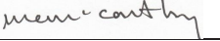
Date: | 20/7/22
Subject Leader: | M. Whittaker
Date: | 1/7/22
Governor: | N. Whittle
Date: | 30/7/22

